PCF fabricated at CGCRI, Kolkata

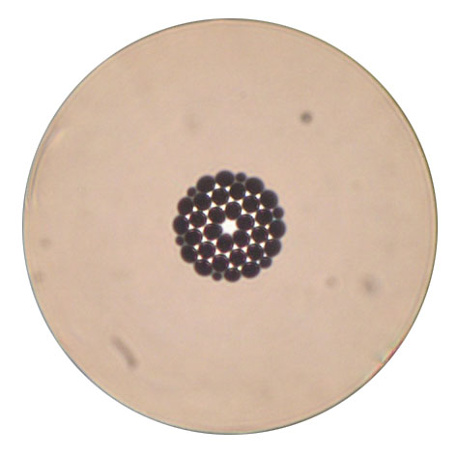

PCF – 19B

Fiber diameter = 123.45 μm
Air hole diameter = 5.06 μm
Pitch = 5.29 μm
Core diameter = 4.37 μm
Air filling fraction = 0.96

