The Value of Mutual Inductance when putting magnetic core between two coils is 5.23E-11Henry and the value of leakage Inductance is 1.10E-6 Henry. Which is shocking because when putting core between conductor, the leakage inductance should smaller as compared to mutual inductance . I have attached the file for your conveniance. Leakage inductance is calculated by short circuiting secondary coil. Mf.VCoil_pri/Ipri*jw
Infinite Element
Air
Core ur=100

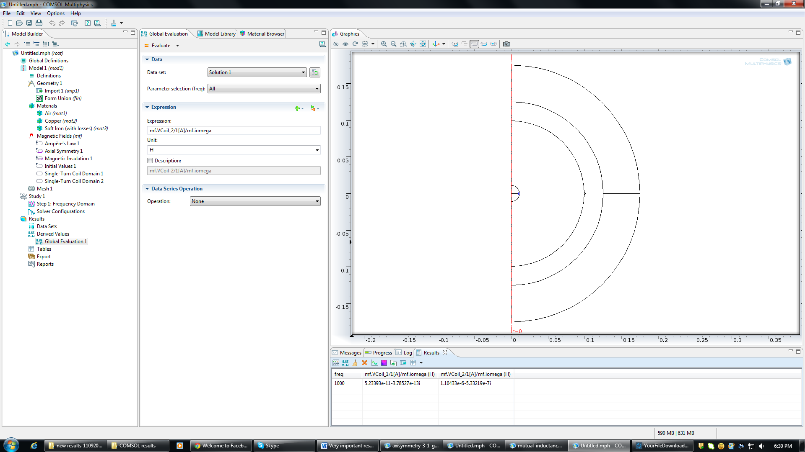
Coil

