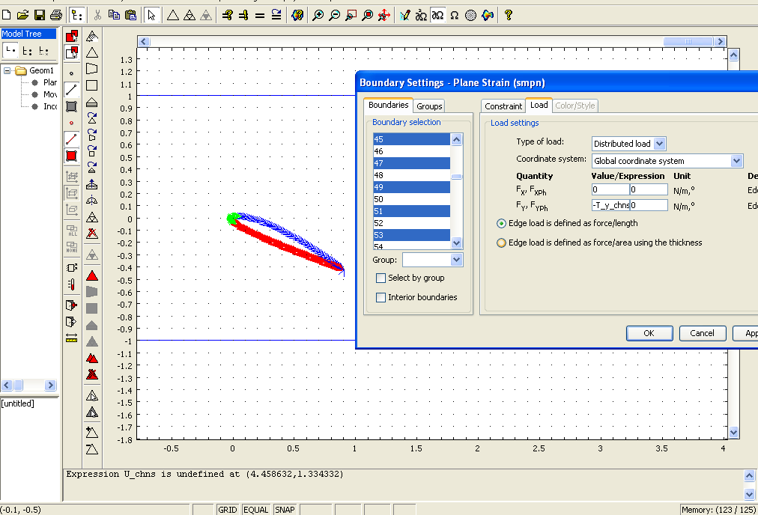

- Force on the bottom of the wing (-T_y_chns).
- Wing (airfoil) held at its radius.

- Movement does not appear for the airfoil (except in a small region on the airfoil). The legend indicates displacement, however.

