I have to get numerical solution for Modified poisson Boltzmann equation ODE with boundary conditions and one constitutive relation for relative permittivity which depend on norms of electric field.
Can you tell how to model it in comsol?

Governing Equation is Modified poisson- boltzmann equation:
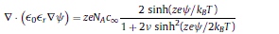

Expression for relative permittivity:

