Hi, everyone,

I add an extrusion coupling operator to extract the dependent variable at a specified boundary with the name of “genext1”. According to the guidance of the document (user’s guidance), I build the extrusion operator in the model and defined a global variable with the name of “TD1” to check whether there is wrong with the operator. All the details are shown in Fig.1.
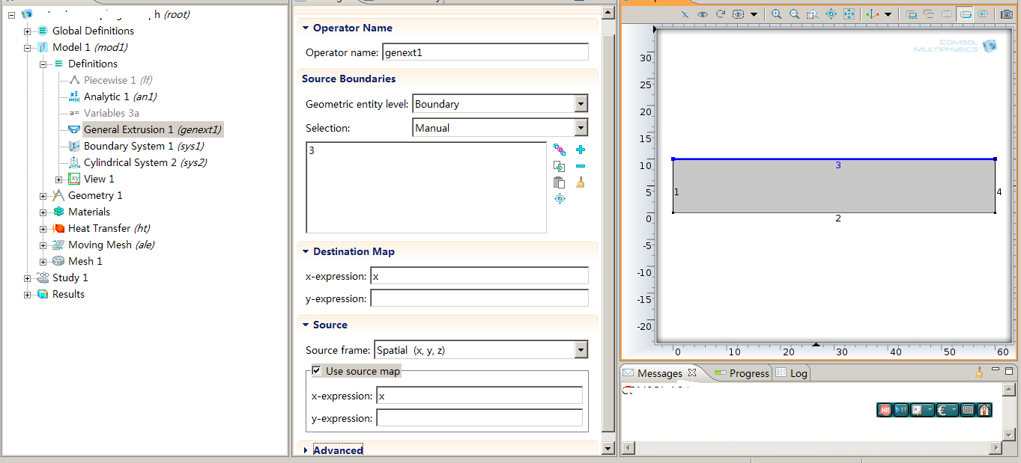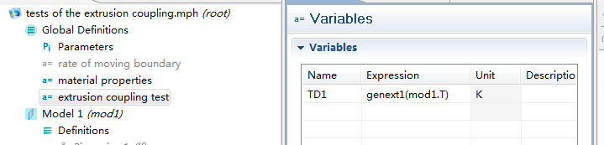§
Global definition of a variable to test its validity
Fig. 1 Coupling operator and global definition
Detailed definition of the general extrusion

After solving the model, I try to visualize the global variable “TD1”, while there are some problems.
Fig. 2 shows the resultant temperature distribution. Because there is heat flux (BC) on the upper boundary, hence the maximum temperature should locate on this boundary.
However, I try to plot “TD1” using line plot and surface plot, only to fail. Fig. 3 shows the results and errors when plot the “TD1” using line and surface plot. In Both situations, the
“Unknown function or operator
-Name: genext1
-Plot: surf1 (Surface)”
error occurs. I am quite puzzle with it. I have defined the global variable “TD1” using the genext1 (general extrusion) operator, and plot the global variable, but fails. The extrusion operator can create a global quantity which can be used in other model. Can it be used in the global definition? This is my first question, thanks for your help.
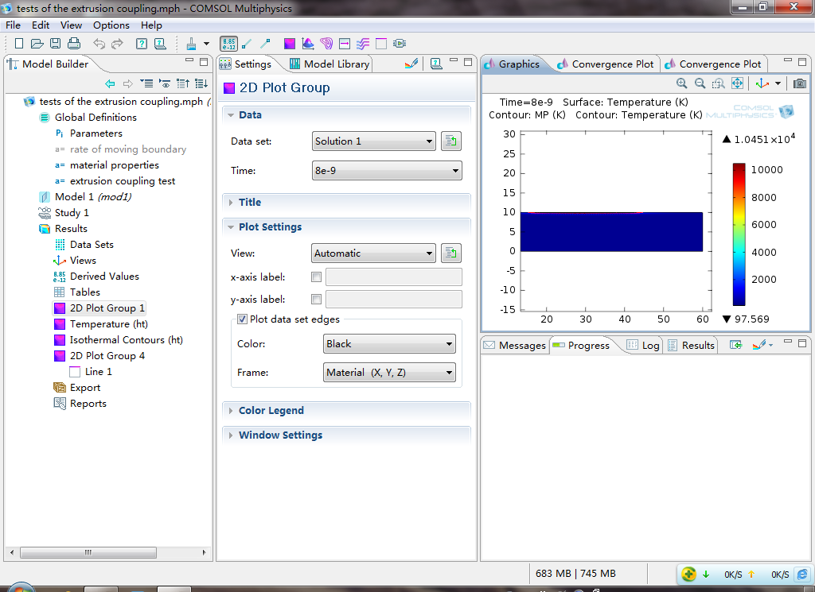
Fig. 1 Temperature distribution after solving

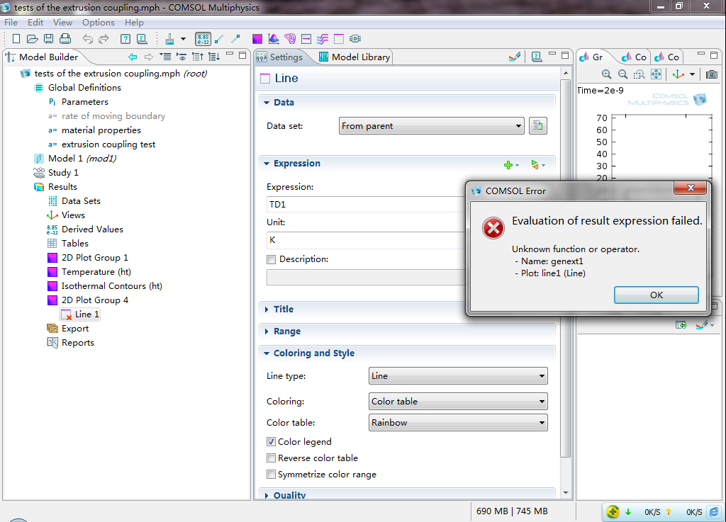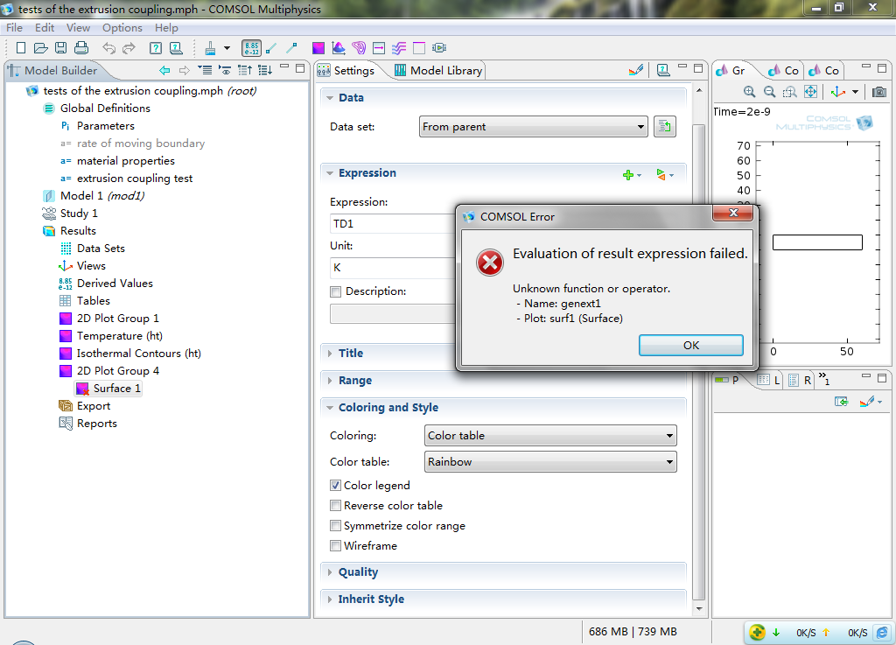
Using line plot
Using surface plot
Fig. 3 Errors when plot TD1 after solving using different plot methods

Afterward, I try to use the “genext1(T)” in the expression instead of T (which is defaulted), and both plots using line and surface plot are ok, just shown in Fig. 4. But after a careful look, the so called boundary temperature (upper surface temperature) is different from the one shown in Fig. 2. The maximum temperature at the upper temperature is 1.0451 X 10e4, while the one obtained through the extrusion operator is 1.0557 X 10e4. The gap (105K) is a little big. I haven’t understood the underlying reason and mistake. Could you give me some guidance?

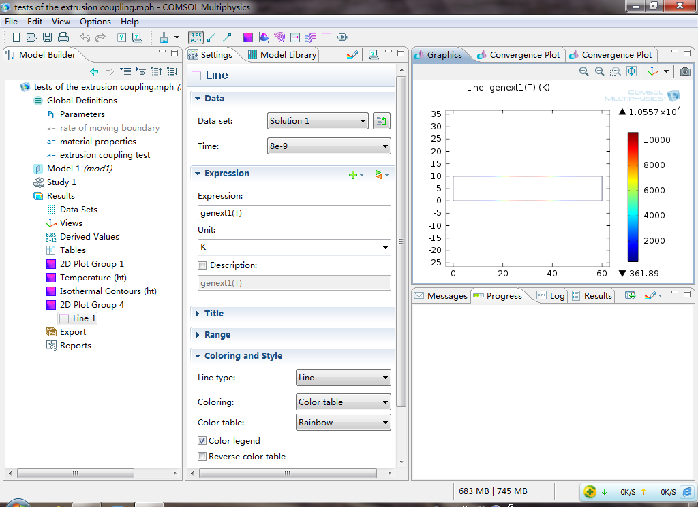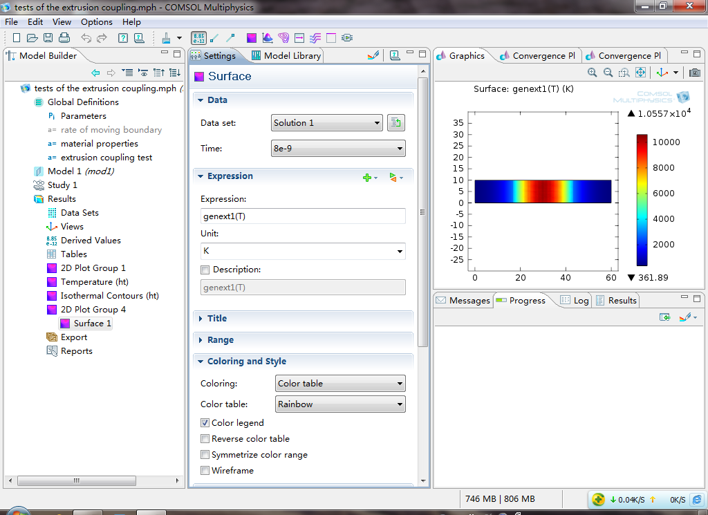
Using line plot
Using surface plot
Fig. 4 genext1(T) plot using different plot methods

Question one:
Can the extrusion operator be used in the global definitions?
If can, why I can’t plot after solving?

Question two:
Why there is a big difference between the actual/theoretical temperature and the one obtained through the extrusion operator?

Thanks sincerely in advance.
Best wishes to you and your family.

Yours
FM Huang
Dec.19th, 2011

