COMSOL Srl  Viale Duca degli Abruzzi, 103  25124 Brescia  Tel. +39-030-3793800  Web: www.comsol.it  E-mail: info@comsol.com | Media Contact  Laura Gabusi  laura.gabusi@comsol.com  Explore the Image Gallery featuring COMSOL Multiphysics simulations: www.comsol.it/press/gallery

COMSOL’s Italian Office Expands to Meet Growing Demand

In response to the continued success of COMSOL Multiphysics in Italy, the Brescia
office expands to provide comprehensive simulation resources for the Italian engineering market

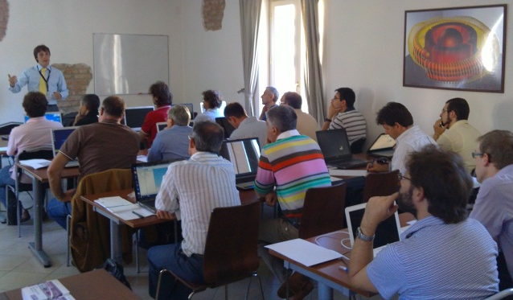
BRESCIA (December 5, 2013) – In March of 2006, COMSOL opened its first Italian office in the city of Brescia, demonstrating the company’s commitment to serving the high-tech engineering market in Italy. Today, in response to a significant increase in demand for the company’s flagship product, COMSOL Multiphysics, COMSOL has announced that the Italian office is expanding. New and larger premises allow hiring top tech talent to provide software sales, excellent customer support, comprehensive training sessions, application-specific seminars, and customer visits.
The attendees of the 2014 training series will be the first to benefit from the new and larger premises. They will advance their simulation skills through a combination of hands-on activities and lectures taught by a growing team of expert instructors

The decision to expand is driven by the company’s dedication to providing outstanding sales and support to Italian research centers, industries, and universities. “One of the key successes of COMSOL Srl is the focus on making sure our customers get the most out of the software, which is especially evident in easy access to highly qualified support,” says Gian Luigi Zanotelli, Managing Director of COMSOL Srl. “We have established close relationships with our customers much thanks to always being available with responsive and friendly sales staff as well as knowledgeable support engineers. I'm sure that this new office will help us to further strengthen this trusted relationship.”

The new Brescia office reflects a broader presence of the software on the Italian market as a whole, and the continued development of the software’s core functionalities makes it an invaluable tool for the simulation projects of engineers working in the automotive, MEMS, biomedical, and mechanical industries. "As an experienced COMSOL user, I think that this expansion of the company resembles the growth of its great software,” says Dr. Ciro Del Vecchio of the Arcetri Astrophysical Observatory at the National Institute for Astrophysics. “I'm sure that it will help growing the user community and bring additional simulation experts to the Italian branch."

About COMSOL
COMSOL provides simulation software for product design and research to technical enterprises, research labs, and universities through 18 offices and a distributor network throughout the world. Its flagship product, COMSOL Multiphysics®, is a software environment for modeling and simulating any physics-based system. A particular strength is its ability to account for coupled or multiphysics phenomena. Add-on products expand the simulation platform for electrical, mechanical, fluid flow, and chemical applications. Interfacing tools enable the integration of COMSOL Multiphysics® simulation with all major technical computing and CAD tools on the CAE market.
~
COMSOL, COMSOL Multiphysics, Capture the Concept, COMSOL Desktop, and LiveLink are either registered trademarks or trademarks of COMSOL AB. All other trademarks are the property of their respective owners, and COMSOL AB and its subsidiaries and products are not affiliated with, endorsed by, sponsored by, or supported by those trademark owners. For a list of such trademark owners, see www.comsol.com/trademarks

